Shaha Jahan Kabir Tamim 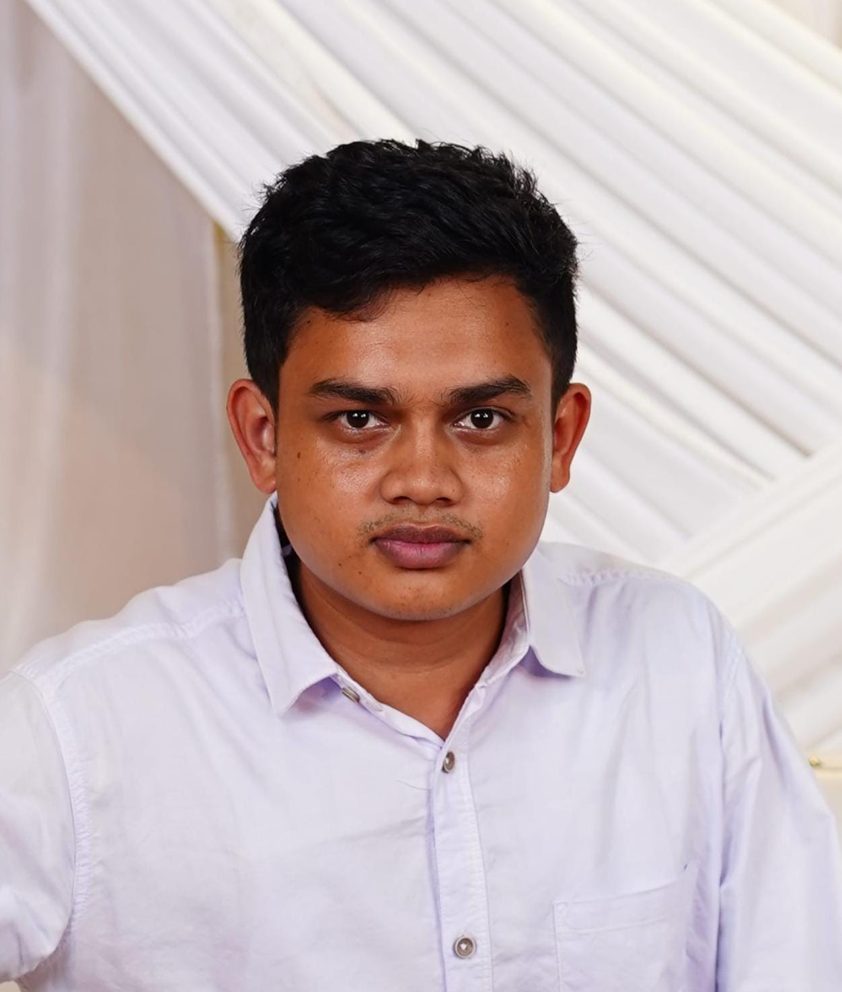

College para, Nilphamari Sadar

Nilphamari, 5300

Phone - 01763139498

Email - mdtamim4590@gmail.com

Github-https://github.com/Shahajahan45

Linkedin-https://bd.linkedin.com/in/md-tamim-64117134a

Fiverr-https://www.fiverr.com/shahajahankabir/buying

**Objective**

A proficient professional with expertise in MS Word, MS Office, MS PowerPoint, and data entry. Experienced in handling complex documentation, streamlining workflows, and delivering accurate and timely results. Adept at multitasking, ensuring efficiency, and contributing to organizational success with precision and attention to detail.

**Education**

Bachelor of Science (BSc)

University name : Nilphamari Govt College

Department name : Chemistry

Session : 2020-2021

Result : 4.00 (Out of 4.0)

Passing year : 2026

Higher School Certificate Examination (H.S.C)

Institution name : Ideal collage jaldhaka

Board : Dinajpur Education Board

Group : Science

Result : 5.00(out of 5.00)

Passing Year : 2020

Secondary School Certificate Examination (S.S.C)

Institution name : Binnakuri B.C.S BL High school

Board : Dinajpur Education Board

Group : Science

Result : 5.00(out of 5.00)

Passing Year : 2018

**Training**

**Computer Fundamentals and Office Applications Training**  
Organized by Bangladesh Computer Council and Center for Digital Transformation (CDT), Begum Rokeya University, Rangpur  
Funded by Enhancing Digital Government & Economy (EDGE) Project  
Year of Completion - 2025

* Gained proficiency in basic computer operations and Microsoft Office applications.
* Hands-on experience with tools like Word, Excel, PowerPoint, and others.
* Learned essential skills for digital government services and economic applications.

**Technical Skills**

* Office Applications: Microsoft Word, Excel, PowerPoint
* Computer Fundamentals: Hardware and software basics, troubleshooting
* Proficient in Microsoft Office Suite (Word, Excel, PowerPoint, Outlook)
* Basic computer troubleshooting
* Understanding of digital government services
* Strong attention to detail and organizational skills
* Excellent communication and teamwork abilities

**Projects:**

**Academic Marksheet**

I make an academic mark-sheet using MS Office 2016.

**Salary Sheet**

I make an academic mark-sheet using MS Office Excel 2016.

**Hostel Maintenance Sheet**

I make a Hostel Maintenance Sheet using MS Office Excel 2016

**Biography Presentation**

I make a biography presentation using MS Office PowerPoint 2016

**Certifications**

* **Computer Fundamentals and Office Applications Training**

**Languages**

* English (Fluent)
* Bangla (Fluent)

**References**

**Reference: 01**

Name - Md.Majedul Islam

Organization - Nilphamari Govt College

Designation - Head of the Dipartment (Physics)

**Reference: 02**

Name - Md. Jahangir Alam

Organization - Nilphamari Govt College

Designation - Associate Professor Of Chemistry



Date: 20.01.2025 shahajahan kabir